DSHP Board Meeting Minutes
3rd Wednesday, 6-8pm
8/20/2024
Roll call and quorum | Roll call and quorum (5 directors)  Call to order by President Veronica Madrigal at 6:05 pm  A quorum was present.  Directors present: Veronica Madrigal, Samantha Teshima, Julia Teshima, Brigitte Ouabo, Brooke Betts  Board members present: Mauricio Ortega, Johnny Wong  Committee Members/Guests: Natalie Sweeney, Jared Garcia, Esther Okoro, Nathalie Yang, Pegah Capaul, Amy Le, Liz Vuong, Barbara Uenaka, Ryan Henry
Approval of Minutes | June 2024 Board Meeting minutes xx approved.  Motion: Natalie Sweeney  Second: Brigitte Ouabo
New business | CSHP Statewide Slides Update (ACP Meeting)  - Veronica reviewed the CSHP statewide slide with updates on upcoming events, CEs, legislative activities, Social Media Platforms, membership outreach, membership benefits, Seminar activities, Pacific Coast Patient Safety Conference  Reminder to sign up for RDC  - RDC 9/21/24 – virtual via Zoom  - HOD at CSHP Seminar Sunday, 1/3/24 from 10:30am – 2pm  CSHP Seminar Ribbons  Newsletter Update  - Veronica showed a preview of Liz’s most recent newsletter  Committee Updates  - Reconfiguring committee members (students, CE)  - Get in touch with Marilyn for CE and have her train a committee of students  Social Media  - Will be creating an Instagram, will utilize more social media to highlight our members, promote upcoming events, share/repost  - Volunteers willing to help with social media – new committee facilitated by Veronica and Brigitte (Pegah, Pardis, Esther)  DEI Survey (Brigitte)  - Please take this survey! Will be used to create CSHP-targeted programming and results will be presented at Seminar  - https://tuc.co1.qualtrics.com/jfe/form/SV_894fpIC8L2jNrIG  - Goal is 200 responses (currently 25)
Liaisons Report Out | CSHP Board (Johnny)  - CSHP leaders/experts working to submit recommendations to Board of Pharmacy using task force  - Standard of Care conversations with GAAC committee and CSHP BOD  - Delegate “orientation” meeting next Wednesday, 9/28 at 6pm (CE session)  Government Affairs (Brigitte)  - Standard of care  - Title 22 – health and safety standards. Hospitals/LTC facilities. Hasn’t been updated in 22 years. GAAC committee going through revisions. 3-part town-hall series to obtain comment and feedback. Final town hall session is 8/21/24 from 12-1pm  Technician (Donna) – not present  New Practitioner (Mauricio – Samantha covering at meeting)  - Tuesday, September 3rd @5:45pm  - Ruth’s Chris Steakhouse, Walnut Creek  - 3 panelists. Currently 10 signed up  Student (Thao, Nathalie)  - Thao. Almost Medicare Part D season. If interested in serving as a preceptor, Tony has the contact information  - Nathalie. Touro Club Day just finished. Clinical skills competition, planning residency roundtable session (likely will be early/mid November, hoping for in person)  Industry (Natalie)  - US drug price negotiations  - Arrowhead shoots for obesity drug.  - WHO declares mpox public health emergency.  - Incyte Hvhd FDA approval.  - Blue bird sickle cell gene therapy lags behind Vertex.  - US approves Gilead Seladelpar.  - Nice green lights first oral prostate.  - Lexicon cuts work force, focus shift to once rejected diabetes drug.  - Enhertu scores gastric cancer approval in China.  - Syros ditches mid stage tamibarotene.  - Galderma is 31 blocker gains FDA approval.  - Lilly’s Mounjaro emerged as Pharma fastest growing drug.  - Novo Nordisc targets filing for this yr, insulin GLP2 combo.  - Citris wins FDA approval for cutaneous T-cell lymphoma drug.  - Halda tops off next gen oral TAC for metastatic castration resistant prostate cancer.  - Alderyra’s dry eye stages comeback with new phase 3 results.  - Red Hill biopharma’s RHB -104 can successfully treat Crohn’s.
Committee Report Out | Membership (Brooke)  - No updates from committee  - We have increased pharmacist/technician membership from May to July this year, but decreased student membership  - Had a discussion brainstorming ways to get more students engaged  - In the past, students who were active on the board helping with events got membership covered (annual student scholarship for Seminar). Can also consider a matching member donation for students  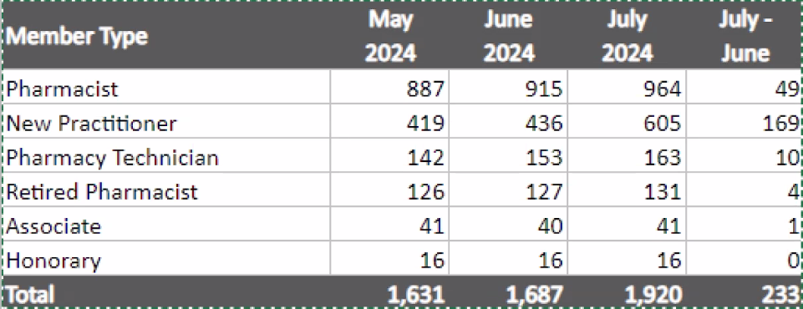  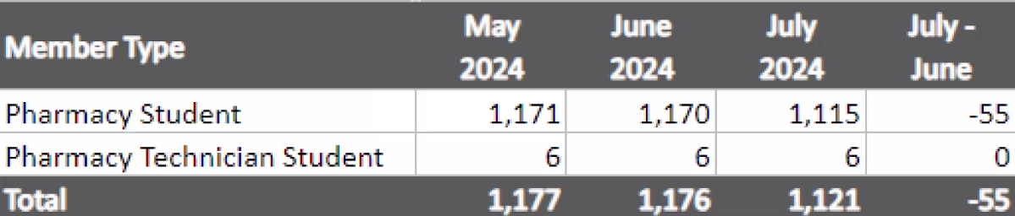  Education (Amy)  - 8/27/24 Nebulization, Theravance, Flemings  - 9/3/24 New Practitioner Event  - 9/11/24 dinner program  - 10/9/24 dinner program  CE/CAPE (Yolanda)  - Oncology forum at the start of the year  - Just need 4 CE hours – 3 need to be available for both pharmacists and pharmacy technicians. May consider the residency lecture series again  Nominations (Brigitte)  - New Practitioner of the Year: Brooke was awarded! Congratulations! Official recognition at the award ceremony at CSHP Seminar  Managers Network (Jared)  - Considering in-person meetings again. Had an industry-sponsored breakfast or lunch pre-pandemic. Sent out a survey to members of the group. Will update everyone  - Currently, September meeting slated to be virtual again  NOWI (Veronica)  - Friday, 9/27, 6-9pm  - Need all hands on deck for either set up or clean up – see Veronica’s email with volunteer details  Community Outreach/Social Events  - Summer BBQ was a success – 8/17/24  - Tony would like to host a winter social (possibly ice rink, bowling, etc…)  - Health fair before Chapter of Distinction due Nov 1  Newsletter (Liz)  - Showed to the group  Webmaster (Jared)  - Newsletter will be included
Next Meeting | Meeting adjourned: 7:42 pm  Next meeting: 9/17/24 @6pm

